Supplementary Data

All methods and Figures on the changes in various parameters characterizing spontaneous and MOG-induced development of experimental autoimmune encephalomyelitis in EAE prone C57BL/6 male mice are taken from [1-3].
- Doronin, V.B.; Parkhomenko, T.A.; Korablev, A.; et. al. Changes in different parameters, lymphocyte proliferation and hematopoietic progenitor colony formation in EAE mice treated with myelin oligodendrocyte glycoprotein. J Cell Mol Med. 2016; 20: 81–94.
- Doronin, V.B.; Korablev, A.; Toporkova, L.B.; Aulova, K.S.; et al. Changes in several disease parameters including abzymes and hematopoietic progenitor colony formation in brain inflammation and demyelination. J. Neurol. Neurol. Disord. 2017, 3, 302.
- Aulova, K.S.; Toporkova, L.B.; Lopatnikova, J.A.; Alshevskaya, A.A.; et al. Changes in cell differentiation and proliferation lead to production of abzymes in EAE mice treated with DNA-Histone complexes. J. Cell Mol. Med. 2018, 22, 5816-32.

A B
CFU-E, erythroid burst-forming unit (late erythroid colonies)
MOG treated
Untreated

BFU-E, erythroid burst-forming unit
Untreated
MOG treated
1200

800
Number of colonies
Number of colonies
900
600

600
400

200 300

0

C
500
CFU-GM, granulocytic-macrophagic colony-forming unit
Untreated
MOG trated
Number of colonies

400

0 10 20 30 40 50 60 70
Time, days

0 10 20 30 40 50 60 70
Time, days
D CFU-GEMM, granulocytic-erythroid-megacaryocytic- 40
macrophagic colony-forming unit
Untreated
MOG treated
Number of colonies

300
20
200

100

0

0 10 20 30 40 50 60 70
Time, days

0
0 10

20 30 40 50 60 70
Time, days

Supplementary Figure S1. In time changes of an average relative content of different colony- forming units of bone marrow progenitor colonies in the case of untreated and MOG-treated male C57BL/6 mice; average number of the colonies corresponding to 7 mice of each group is given and types of progenitor colonies (BFU-E (A), CFU-E (B), CFU-GM (C), and CFU- GEMM (D) are shown [1-3].

A A
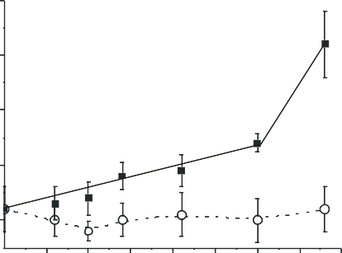0.5 450
0.
0.4
Abs against DNA
0.
0.3
MOG-treated mice
0.
0.2
Control untreated mice
0.
0.1
B
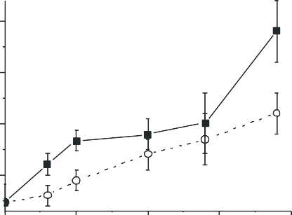
450
A
20

15

Abs against MOG

MOG-treated mice
10

05
Control untreated mice

5 10 15 20 25 30 35 40
Time, days
C D
A450
0 10 20 30 40
Time, days

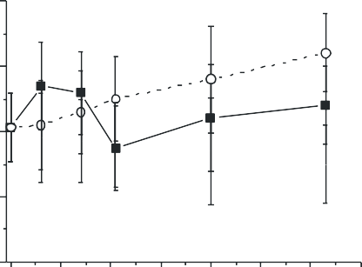A
450
Anti-histones Abs
Control untreated
MOG-treated

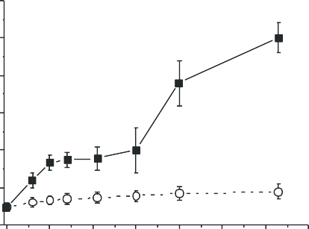0.30 0.4
Anti-MBP Abs

MOG-treated
Cjntrol untreated

0.25
0.3
0.20

0.15 0.2

0.10

0.05

0.1

0.00

0 10 20 30 40 50 60 70
Time, days
0.0

0 10 20 30 40 50 60 70
Time, days

Supplementary Figure S2 The in-time changes in average values of anti-DNA (A), anti-MOG (B), anti-MBP (C), and anti-histones (D) Abs concentration in C57BL/6 male mice before and after their immunization with MOG [1-3].

A RA, %
B RA, %

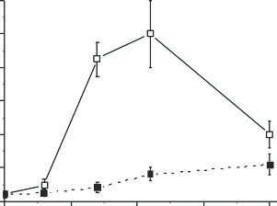
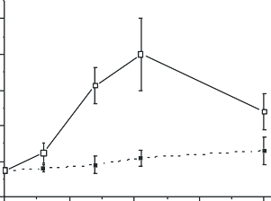120
Hydrolysis of MOG

MOG-treated mice
Control untreated mice

100

80

60

40

Hydrolysis of DNA

50

MOG-treated mice
40

30

20

Control untreated mice
20 10

0
0 10 20 30 40
Time, days

0
0 10 20 30 40
Time, days

C
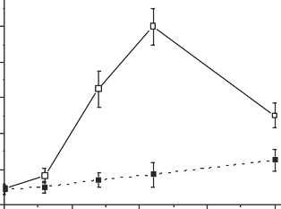
RA, %

100

80

Hydrolysis of MBP MOG-treated mice

60

40

20
0 Control untreated mice
0 10 20 30 40
Time, days

Supplementary Figure S3 The in-time changes in average relative activities (RA) in the hydrolysis by IgGs from sera of C57BL/6 male mice of DNA (A), MOG (B), and MBP (C) before and after mice immunization with MOG [1-3].

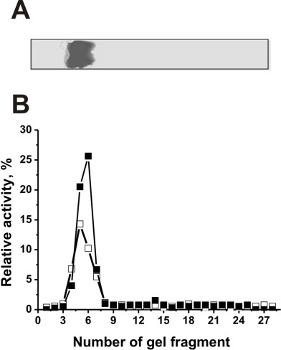

SupplementaryFigure S4. The IgG_{mix} (14 μg) homogeneity analysis by SDS-PAGE under non-reducing conditions in the absence of DTT (A); silver staining. Panel A demonstrates the position of IgGs. The relative activities (RA, %) in the hydrolysis of five histones (■) and MBP (□) were estimated using eluates of gel fragments (2-3 mm) (B). After incubation for 24 h with eluates, complete hydrolysis of all substrates was taken for 100% (B). The errors of the relative activities estimation from two independent experiments did not exceed 7–10%.

